C Program Exercise :

1. WAP for hello world or this is my first C Program.

#include <stdio.h>

int main() {

printf("Hello, world!\n");

printf("Himanshu Jain\n");

return 0;

}

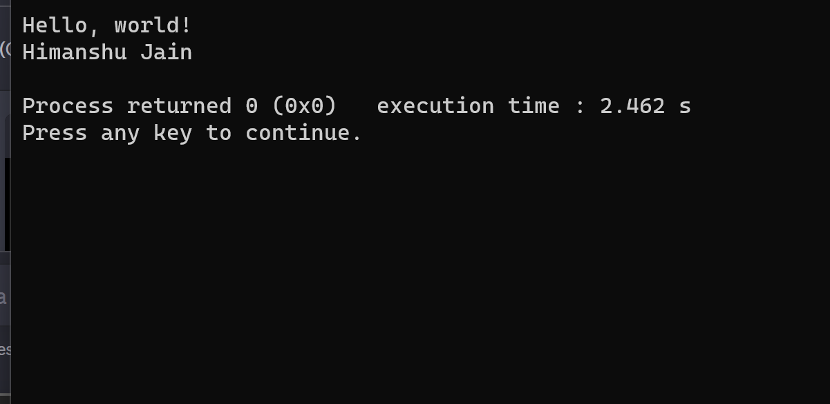

1. WAP to add two numbers.

#include <stdio.h>

int main() {

int num1, num2, sum;

printf("Enter the first number: ");

scanf("%d", &num1);

printf("Enter the second number: ");

scanf("%d", &num2);

printf(“himanshu jain”);

sum = num1 + num2;

printf("The sum of %d and %d is: %d\n", num1, num2, sum);

return 0;

}

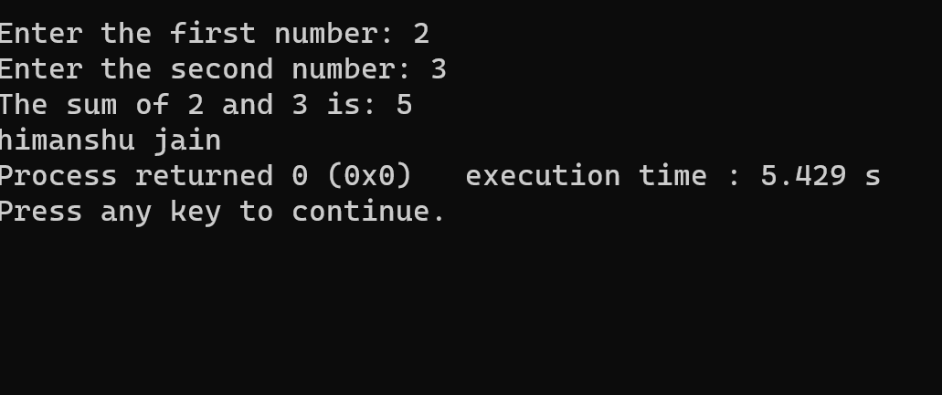

1. WAP to find area of circle.

#include <stdio.h>

int main() {

float pi=3.14 , radius, area;

printf("himanshu jain");

printf("enter the value for radius");

scanf("%f",&radius);

area =pi\*radius\*radius;

printf("the area of circleis %d",area);

}

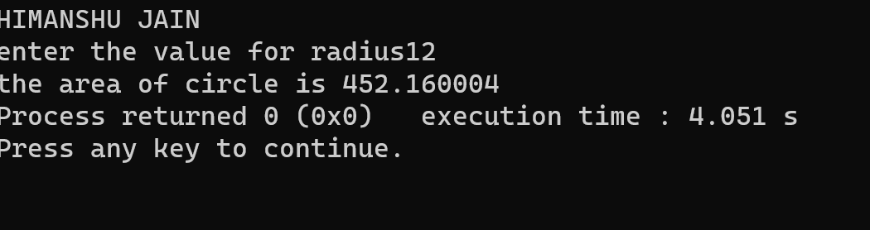

1. WAP to divide two numbers

#include <stdio.h>

int main() {

double num1, num2, result;

printf("HIMANSHU JAIN \n");

printf("Enter the first number: ");

scanf("%f", &num1);

printf("Enter the second number: ");

scanf("%f", &num2);

result = num1 / num2;

printf("Result of %f divided by %f is %f\n", num1, num2, result);

}

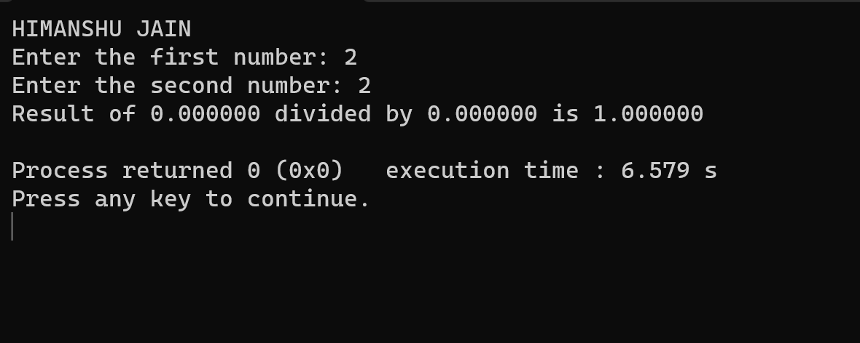

1. WAP to print ASCII value

#include <stdio.h>

int main() {

char character;

printf(“HIMANSHU JAIN\n”)

printf("Enter a character: ");

scanf("%c", &character);

printf("The ASCII value of '%c' is %d.\n", character, character);

return 0;

}

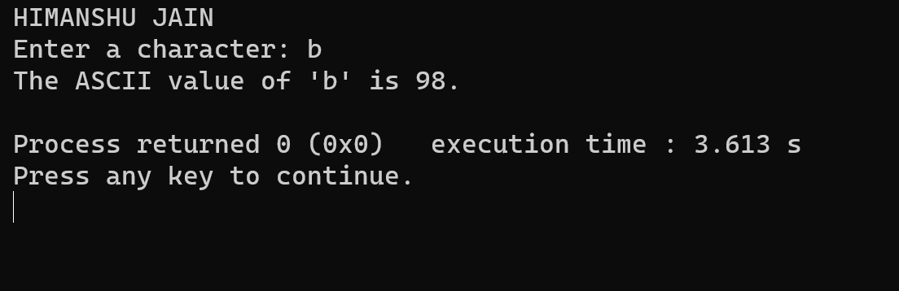

1. WAP to multiply floating point numbers.

#include <stdio.h>

int main() {

float num1, num2, result;

printf(“HIMANSHU JAIN\n”);

printf("Enter the first floating-point number: ");

scanf("%f", &num1);

printf("Enter the second floating-point number: ");

scanf("%f", &num2);

result = num1 \* num2;

printf("The result of %f multiplied by %f is %f\n", num1, num2, result);

return 0;

}

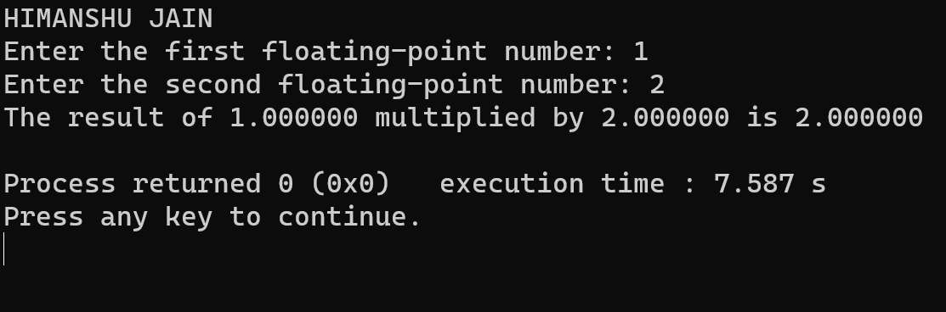

1. WAP to SWAP two vairables number by using third variable.

#include <stdio.h>

int main() {

int num1, num2, temp;

printf(“HIMANSHU JAIN\n”);

printf("Enter the first number: ");

scanf("%d", &num1);

printf("Enter the second number: ");

scanf("%d", &num2);

printf("Before swapping: num1 = %d, num2 = %d\n", num1, num2);

// Swapping using a third variable

temp = num1;

num1 = num2;

num2 = temp;

printf("After swapping: num1 = %d, num2 = %d\n", num1, num2);

return 0;

}

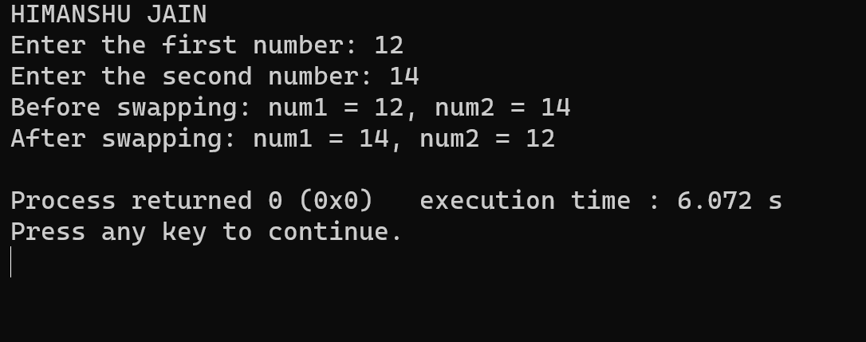

1. WAP to SWAP two vairables number without using third variable.

include <stdio.h>

int main() {#

int num1, num2;

printf("HIMANSHU JAIN\n");

printf("Enter the first number: ");

scanf("%d", &num1);

printf("Enter the second number: ");

scanf("%d", &num2);

printf("Before swapping: num1 = %d, num2 = %d\n", num1, num2);

// Swapping without a third variable using addition and subtraction

num1 = num1 + num2;

num2 = num1 - num2;

num1 = num1 - num2;

printf("After swapping: num1 = %d, num2 = %d\n", num1, num2);

return 0;

}

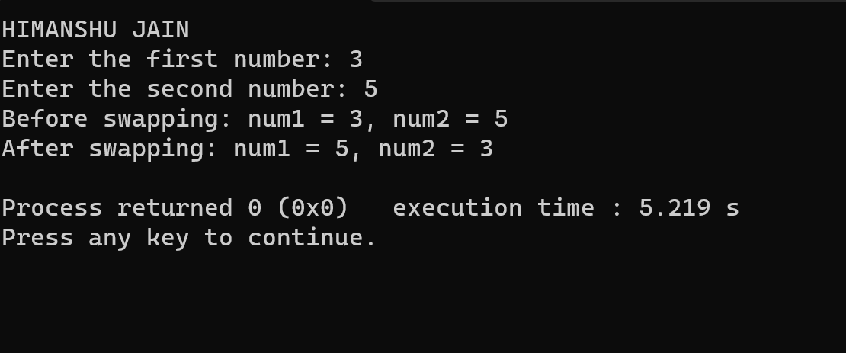9.WAP to SWAP three vairable numbers without using third variables.

include <stdio.h>

int main() {#

int num1, num2;

printf("HIMANSHU JAIN\n");

printf("Enter the first number: ");

scanf("%d", &num1);

printf("Enter the second number: ");

scanf("%d", &num2);

printf("Before swapping: num1 = %d, num2 = %d\n", num1, num2);

// Swapping without a third variable using addition and subtraction

num1 = num1 + num2;

num2 = num1 - num2;

num1 = num1 - num2;

printf("After swapping: num1 = %d, num2 = %d\n", num1, num2);

return 0;

}



1. Wap to find the area of rectangle

#include <stdio.h>

int main() {

double length, width, area;

printf("HIMANSHU JAIN\n");

printf("Enter the length of the rectangle: ");

scanf("%f", &length);

printf("Enter the width of the rectangle: ");

scanf("%f", &width);

area = length \* width;

printf("The area of the rectangle with length %f and width %.2lf is %.2lf square units.\n", length, width, area);

return 0;

}.

